Lightweight Gate
Version 1.0.2

Welcome
Thank you for downloading this fine plug-in. Lightweight Gate is a dynamic processor VST plugin optimized for low CPU usage maintaining the highest precision in signal processing. With a free adjustable knee it is unique in this class.
In order to get the most out of the Lightweight Gate, please spend a few moments reading this brief manual.

License
The pre-compiled Lightweight Gate has a very simple license:

- Lightweight Gate is freeware. This means that you are free to use this plugin in any context. Also you are free to share it on a personal base (ie. give it to friends). However, only the entire unaltered archive, including this document, may be shared. Public redistribution is only allowed on request.
- Copyright of the code and the pre-compiled plug-in remain property of the Delphi ASIO & VST Project and namely Christian-W. Budde.
- This plug-in is provided at no cost; therefore the author Christian-W. Budde assume no responsibility for any negative effects that may occur to the end user or the equipment used to run the plug-in.
- Magazine editors are welcome to include the plug-in on cover mount discs or similar media; However, it is mandatory to inform the author Christian-W. Budde about this. A copy of the publication is always appreciated, but not expected.

User Interface
The user interface shows all adjustable parameters and a readout for the characteristic curve. There are no meters available to maintain the lowest possible CPU usage without wasting too much CPU cycles. Either a dedicated analyse plugin or the build in meters can be used for this task.
Here is a commented screenshot:
Release Time
(50 µs - 5 s)
Attack Time
(10 µs - 1 s)
Characteristic Curve Plot
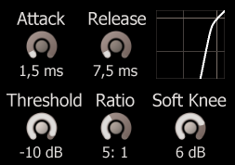
Soft Knee
(0 dB – 10 dB)

Threshold
(-90 dB - +10 dB)
Ratio
1:1 – 1:100

The dials can be adjusted by clicking and dragging up and down on a dial. To reset the dials to their defaults hold the [Ctrl] key while clicking on the dial. Holding the [Shift] key enters the fine tune mode.
Below any dial a read out shows the exact value of a parameter.
The switches can be toggled by simply clicking the LED or the text.
NOTE: When the plugin is in 'Auto Gain' mode it is not possible to manually adjust the make up gain.

The parameters
This plugin features five adjustable parameters in two categories. The categories are 'Time Constants' containing the 'Attack' and 'Release' parameter and the category 'Characteristic' containing 'Threshold', 'Ratio' and 'Soft Knee'.

Time Constants
The time constants control the detector stage. The attack and release times are responsible for how fast the gate reacts and how long it takes to recover.

Attack Time
The attack time controls the duration until the gate reaches 50% of the level below the threshold. Internally it is implemented as a simple envelope follower based on a first order filter with a very low frequency (tuned by the attack time). Compared to other manufacturers this time may differ, so take care while comparing this gate with other gate.

Release Time
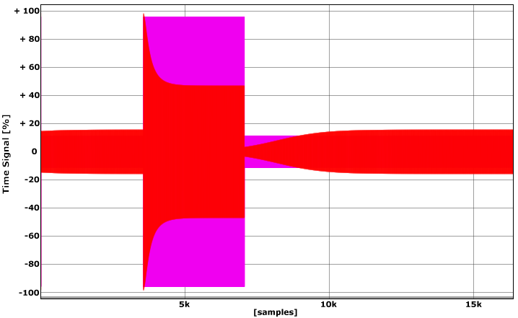
The release time controls the duration until the gate recovers if the input falls below the threshold. It is implemented identical to the attack stage (see above).
Attack Phase
Release Phase

Characteristic
The characteristic curve (as directly shown on the GUI) can be controlled independently by 3 dedicated parameters.

Threshold
The threshold is the level below which gating takes place. A low value (for example -90 dB) means that there is hardly any gating, while a high setting (e.g. -10 dB) means that the signal is nearly gated all the time.

Ratio
The ratio determines the input/output ratio for signals below the threshold. In this plugin the ratio can be adjusted between 1:1 to 1:100. For example, if the signal is 1 dB below the threshold it will be attenuated to even 6 dB below the threshold in case of a 1: 6 ratio setting.

Soft Knee
Around the threshold it is sometimes desired to have a slow transition towards the selected ratio. In case of a value below the threshold the ratio slowly increases if the level increases. Especially for higher ratios the audible change from ungated to gated can be reduced.
The soft knee parameter in dB is the margin below the given threshold. This usually results in a lower level compared to a rather hard knee. This holds especially if the input signal is around the threshold. Keep this in mind when comparing hard vs. soft knee.

Feedback / Bug Reports
I am always eager to hear feedback or have bugs reported. The easiest way is to send me a mail to: Christian@aixcoustic.com
Furthermore feel free to download the source code, that can be found in the Delphi ASIO & VST Project at sourceforge.net.

Version History
  - First release!
1.0.1 Optimizations, Manual added
1.0.2 Renamed 'Fast' to 'Lightweight'

Credits
• Programming: Christian W. Budde
• Additional Framework Programming: Tobias Fleischer, Maik Menz
• Special Thanks: Swen Müller, Duncan Parsons, Laurent de Soras
• Documentation based on a template by Greg Pettit

VST name and technology © Steinberg GmbH
The VST logo is a trademark of Steinberg GmbH

